|  |
| --- |
| ISUBU |
| Mobil Programlama 1 Vize Sınav |
| ***Halit Çetiner***  AD SOYAD: ALİ BARAN  NO: 1915010061 |

## ÇALIŞAN EKRAN GÖRÜNTÜLERİ (20puan)

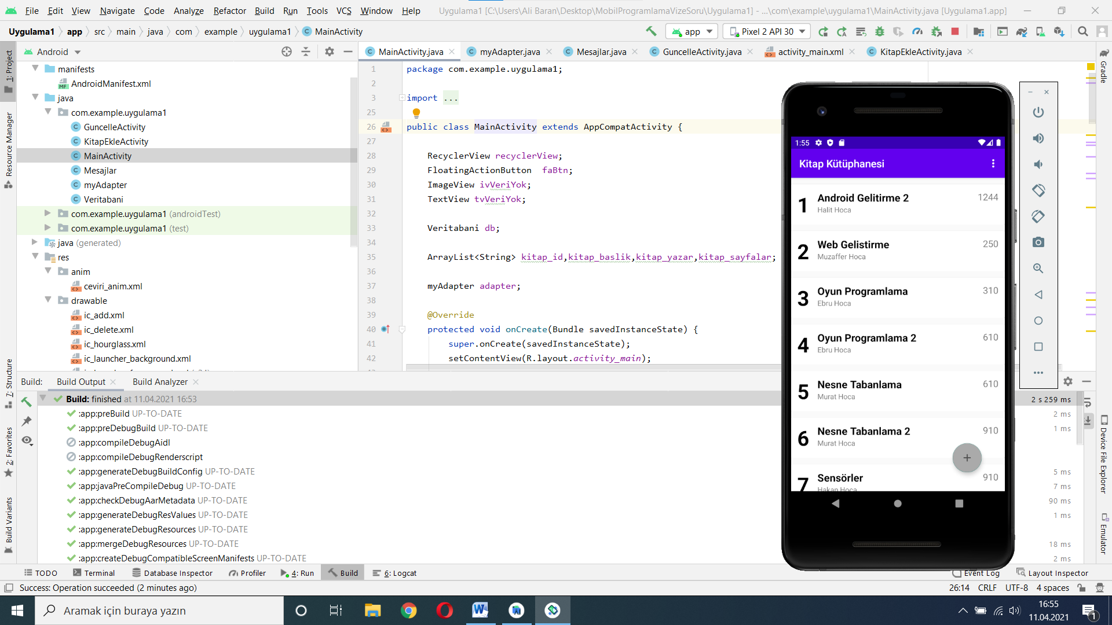

**Şekil 1. Çalışan Ekran Görüntüsü Formatı**

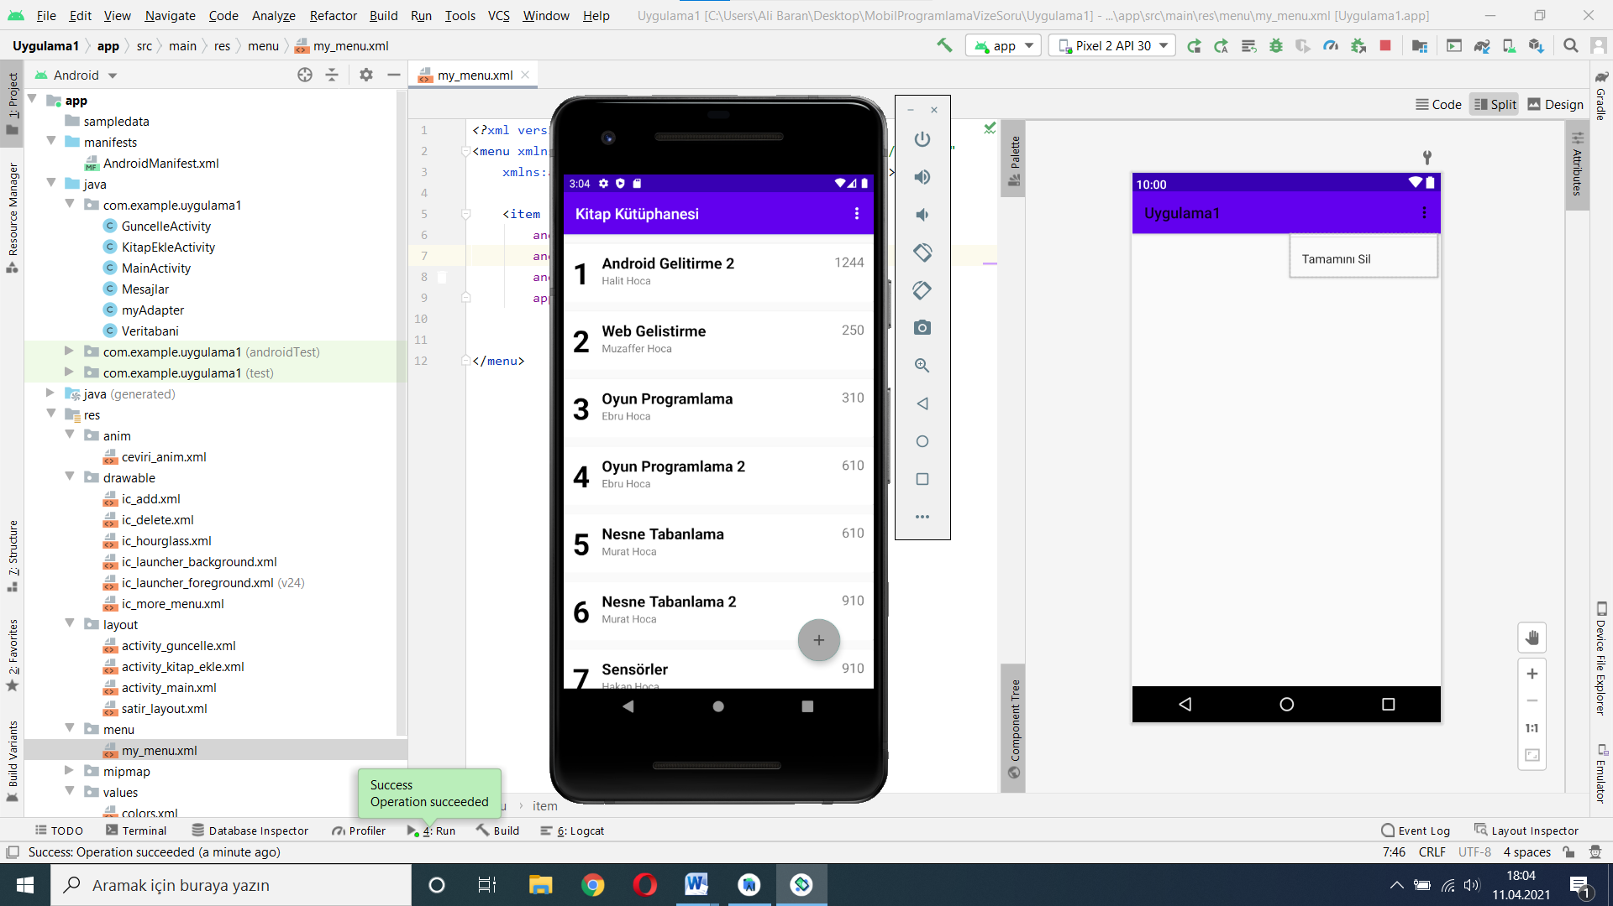

**Şekil 2.Güncelleme Öncesi, ana ekran satır seçimi ve güncelleme ekranına geçiş**

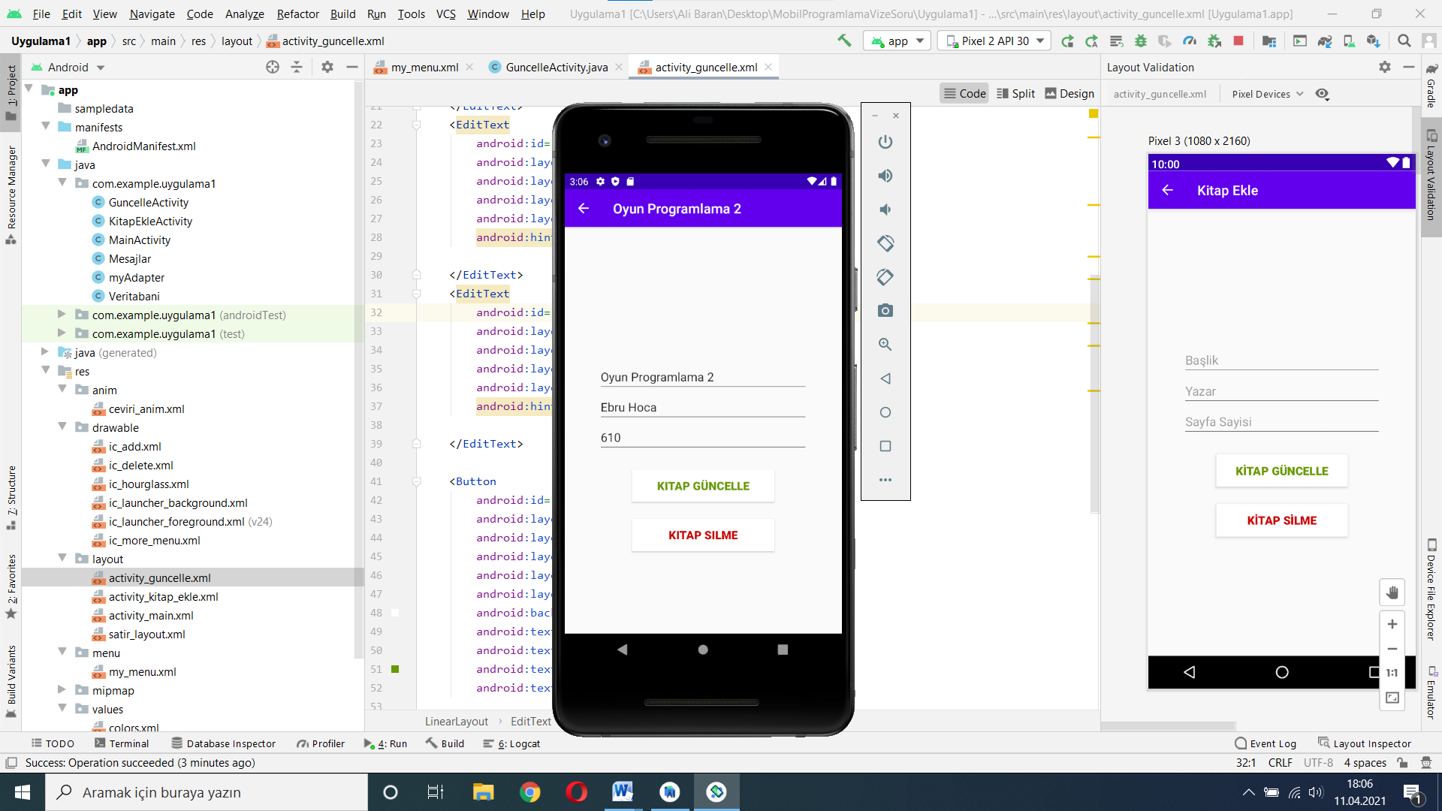

**Şekil 3.Güncelleme Veri Giriş Ekranı**

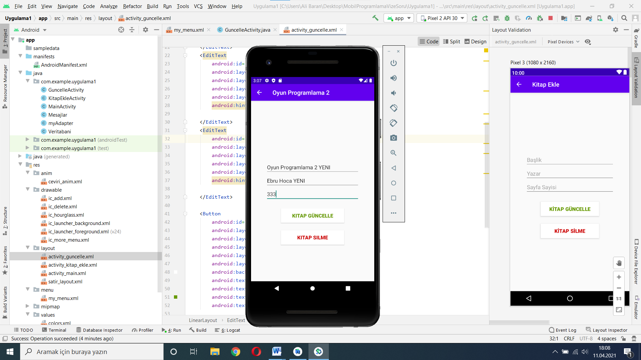

**Şekil 4.Güncelleme Veri Giriş Ekranı GÜNCELLENMİŞ**

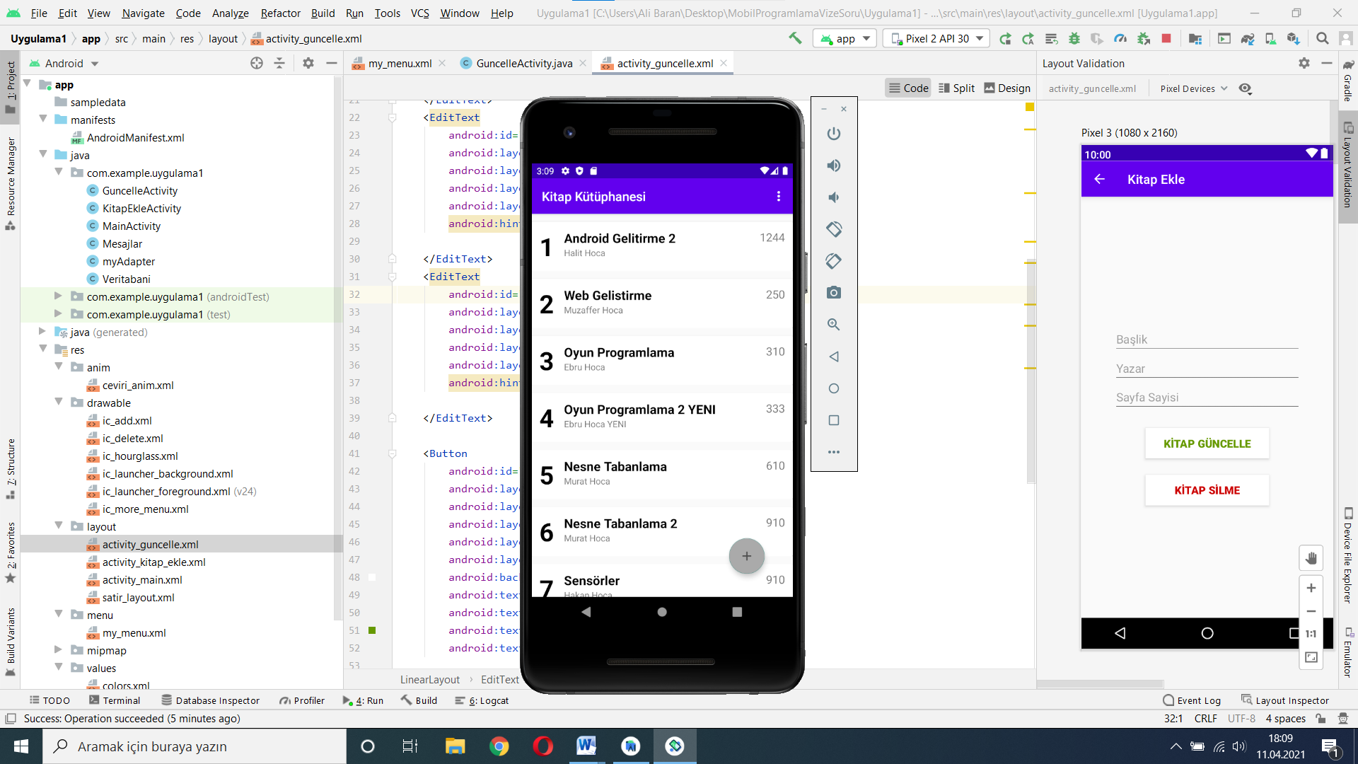

**Şekil 5.Güncelleme Sonrası, Ana Ekran**

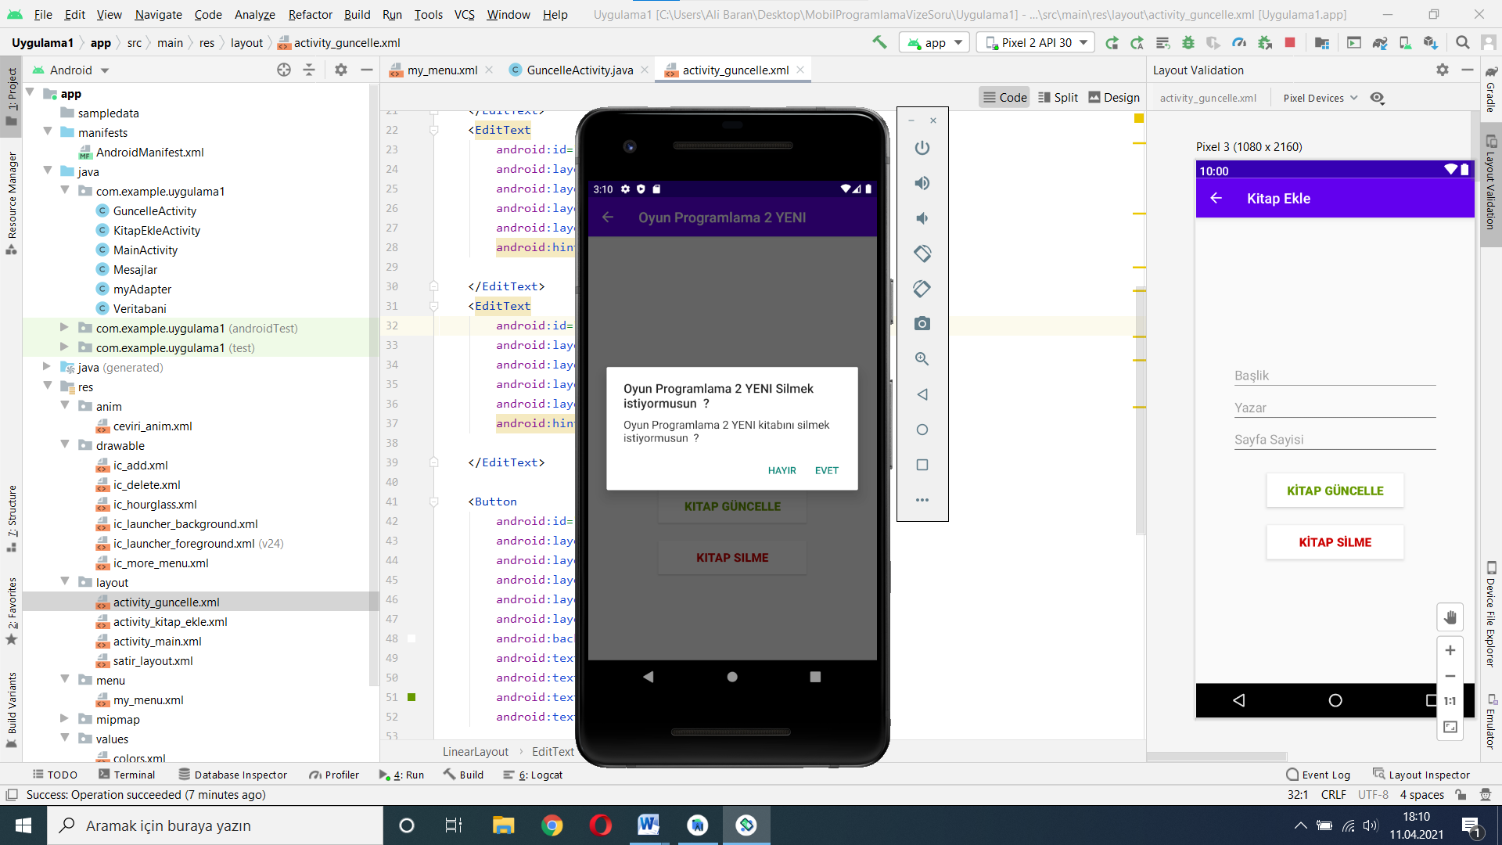

**Şekil 6.Silme sonrasında uyarı ekranı**

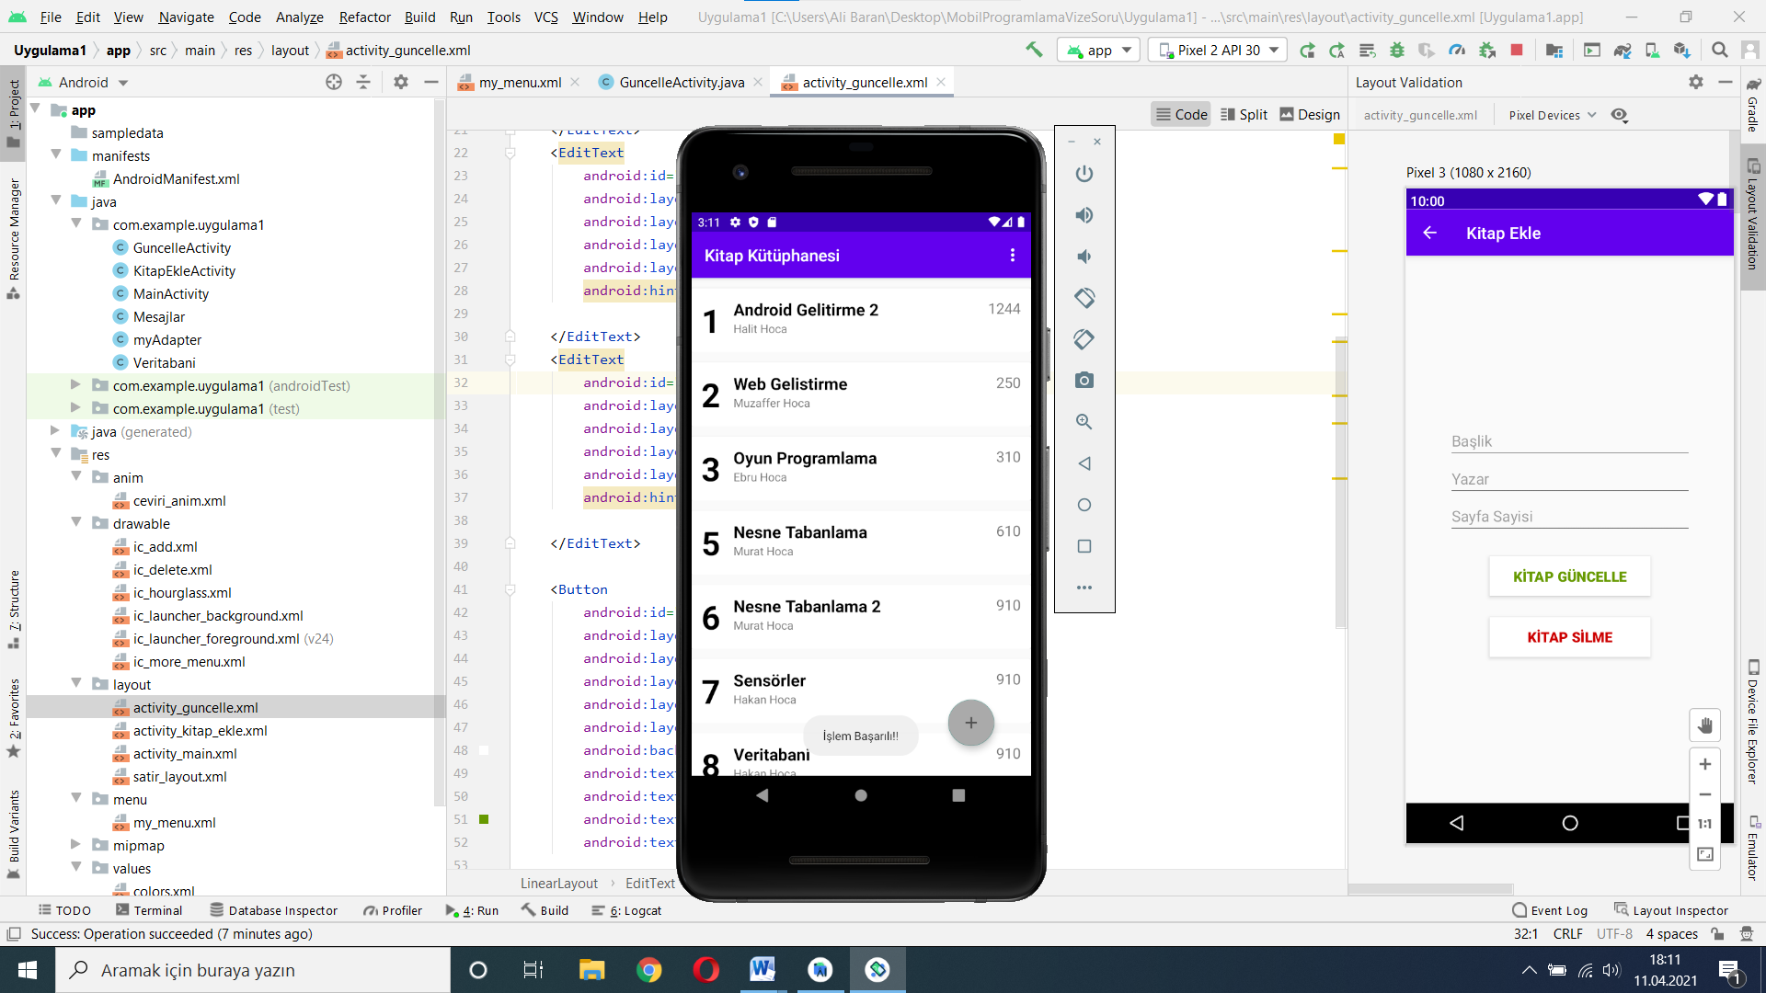

**Şekil 7.Silme sonrasında Ana ekranı DÖNER**

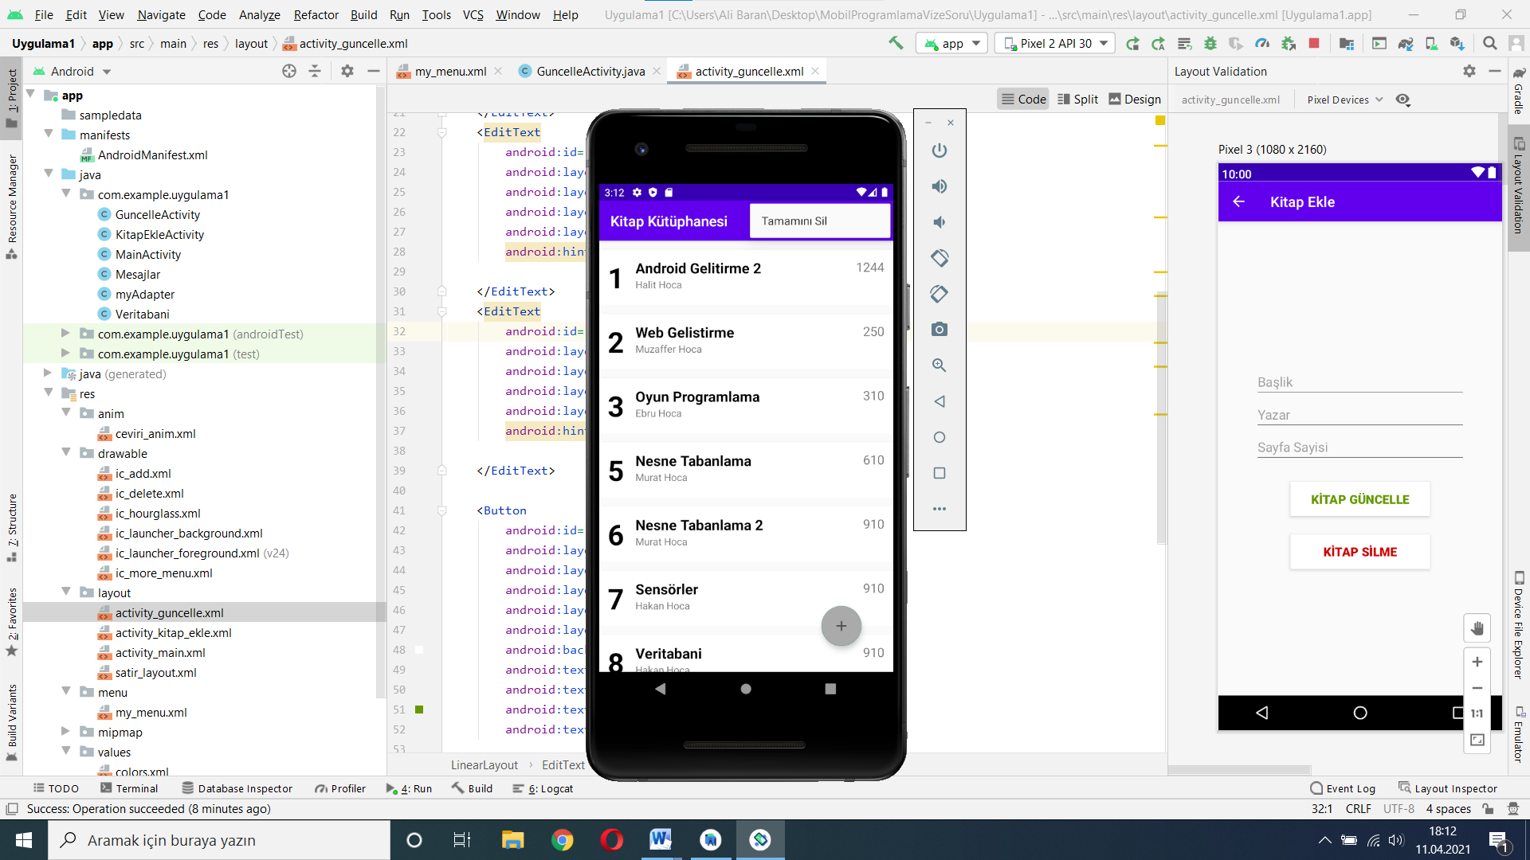

**Şekil 8.Tamamını Silme Öncesi**

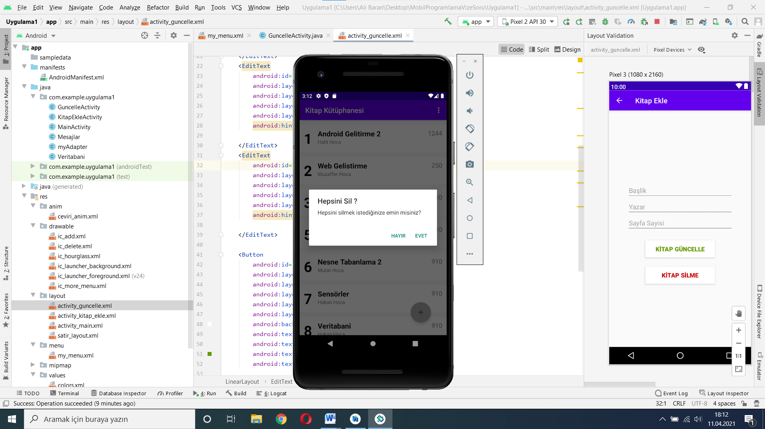

**Şekil 9.Tamamını Silme Dialog**

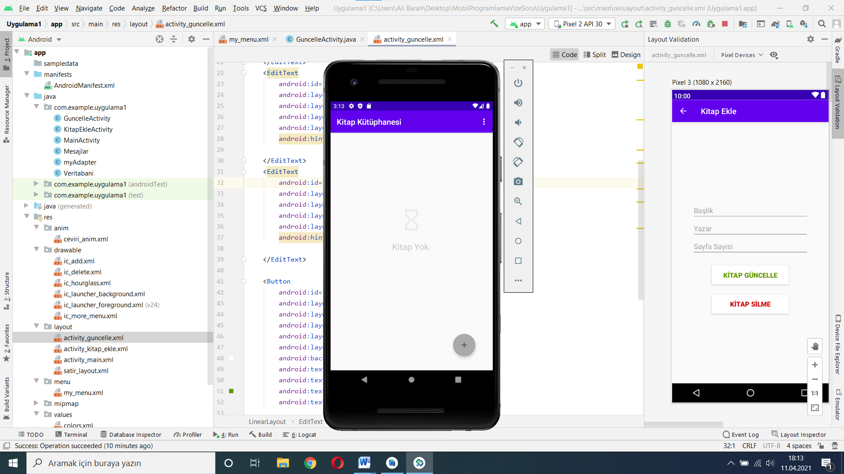

**Şekil 10.Tamamını Silme Sonrası**

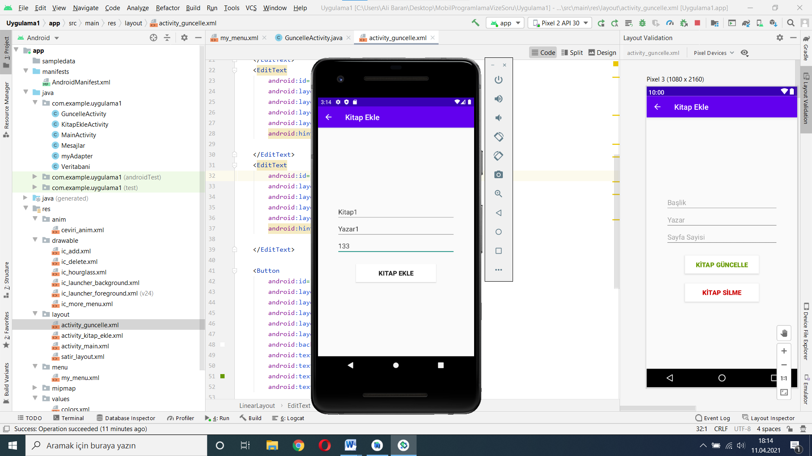

**Şekil 11.EKLEME ÖNCESİ**

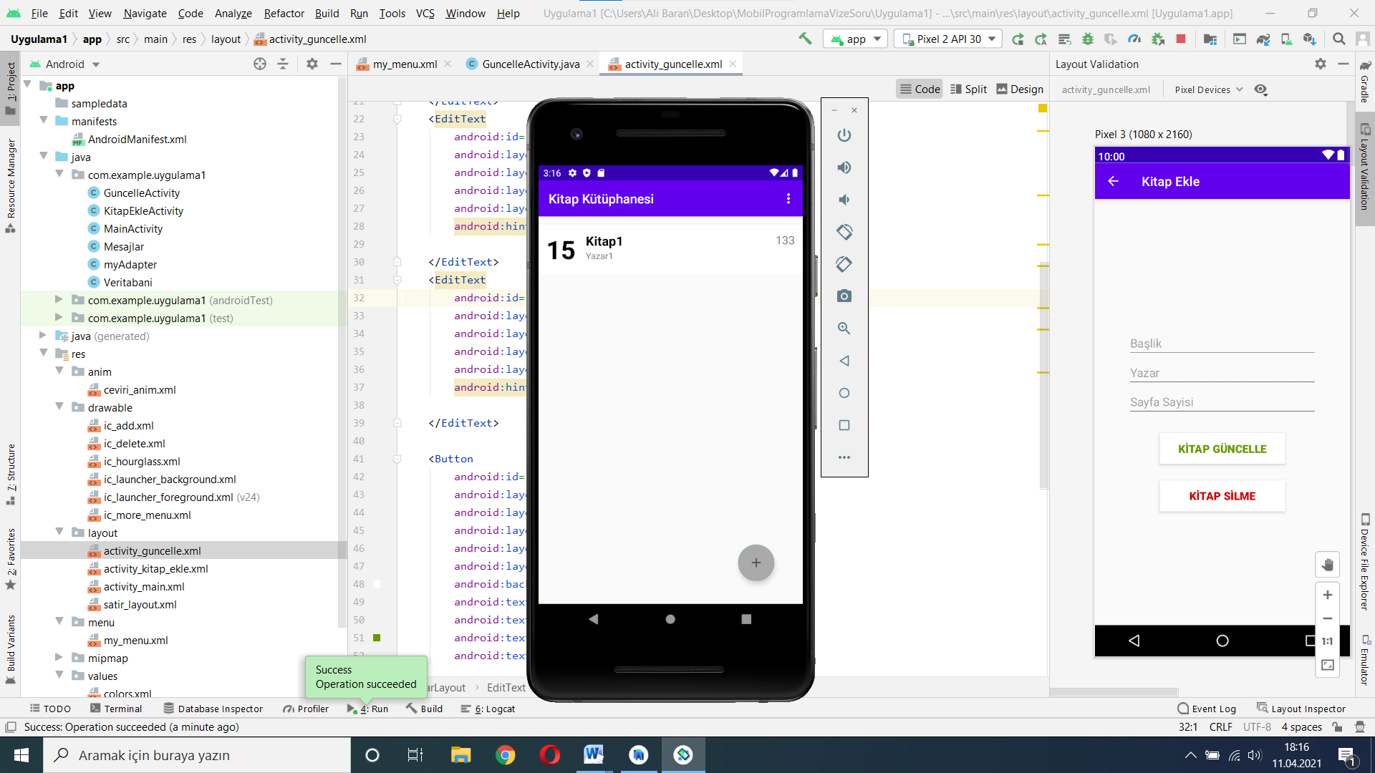

**Şekil 12.EKLEME SONRASI**

## String.xml

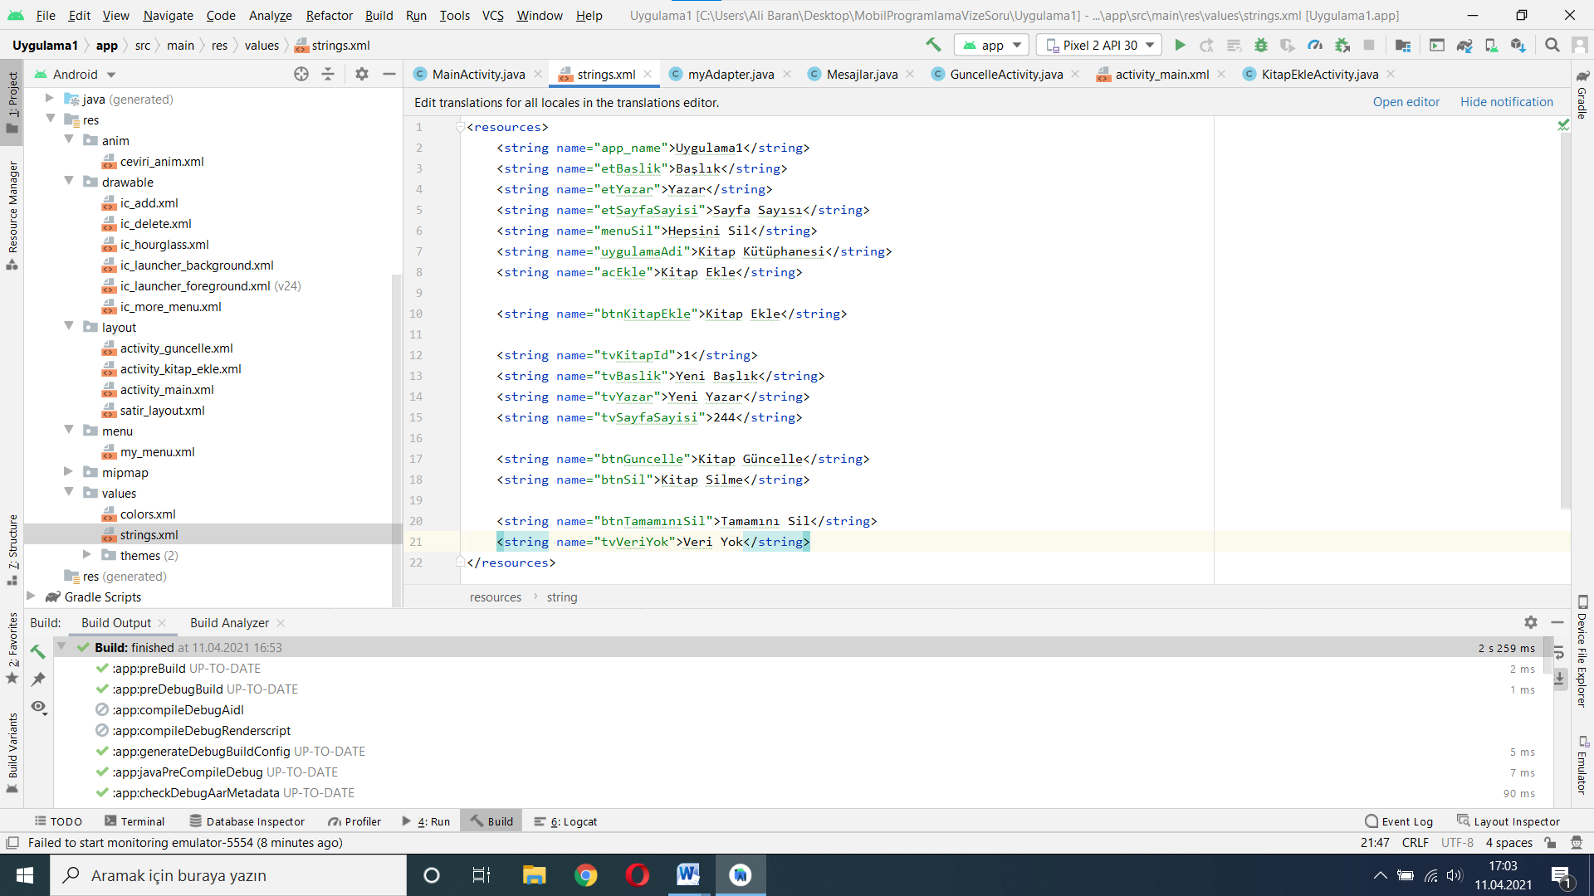

**Şekil 13.String.xml**

## ceviri_anim.xml (Animasyon Dosyası) (10 puan)

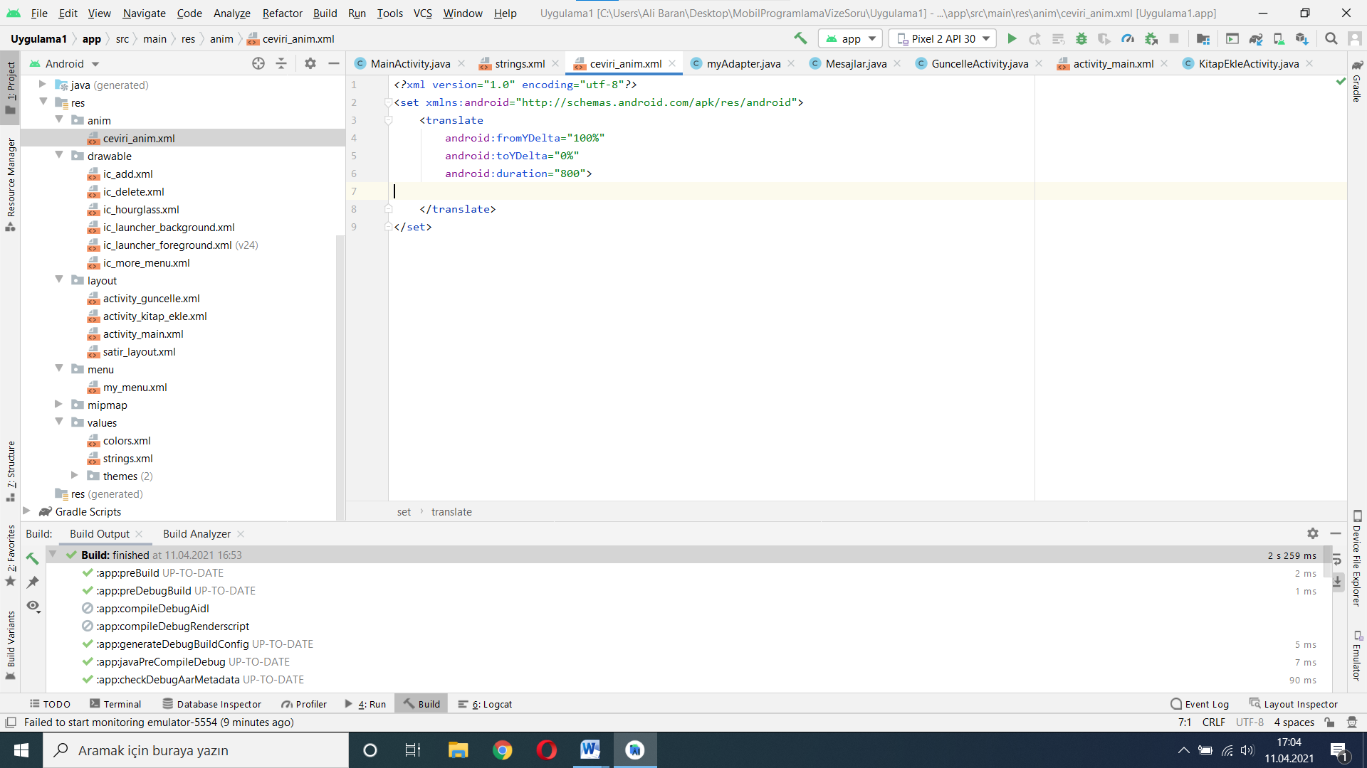

**Şekil 14.ceviri_anim.xml**

## Activity_main.xml (30 puan)

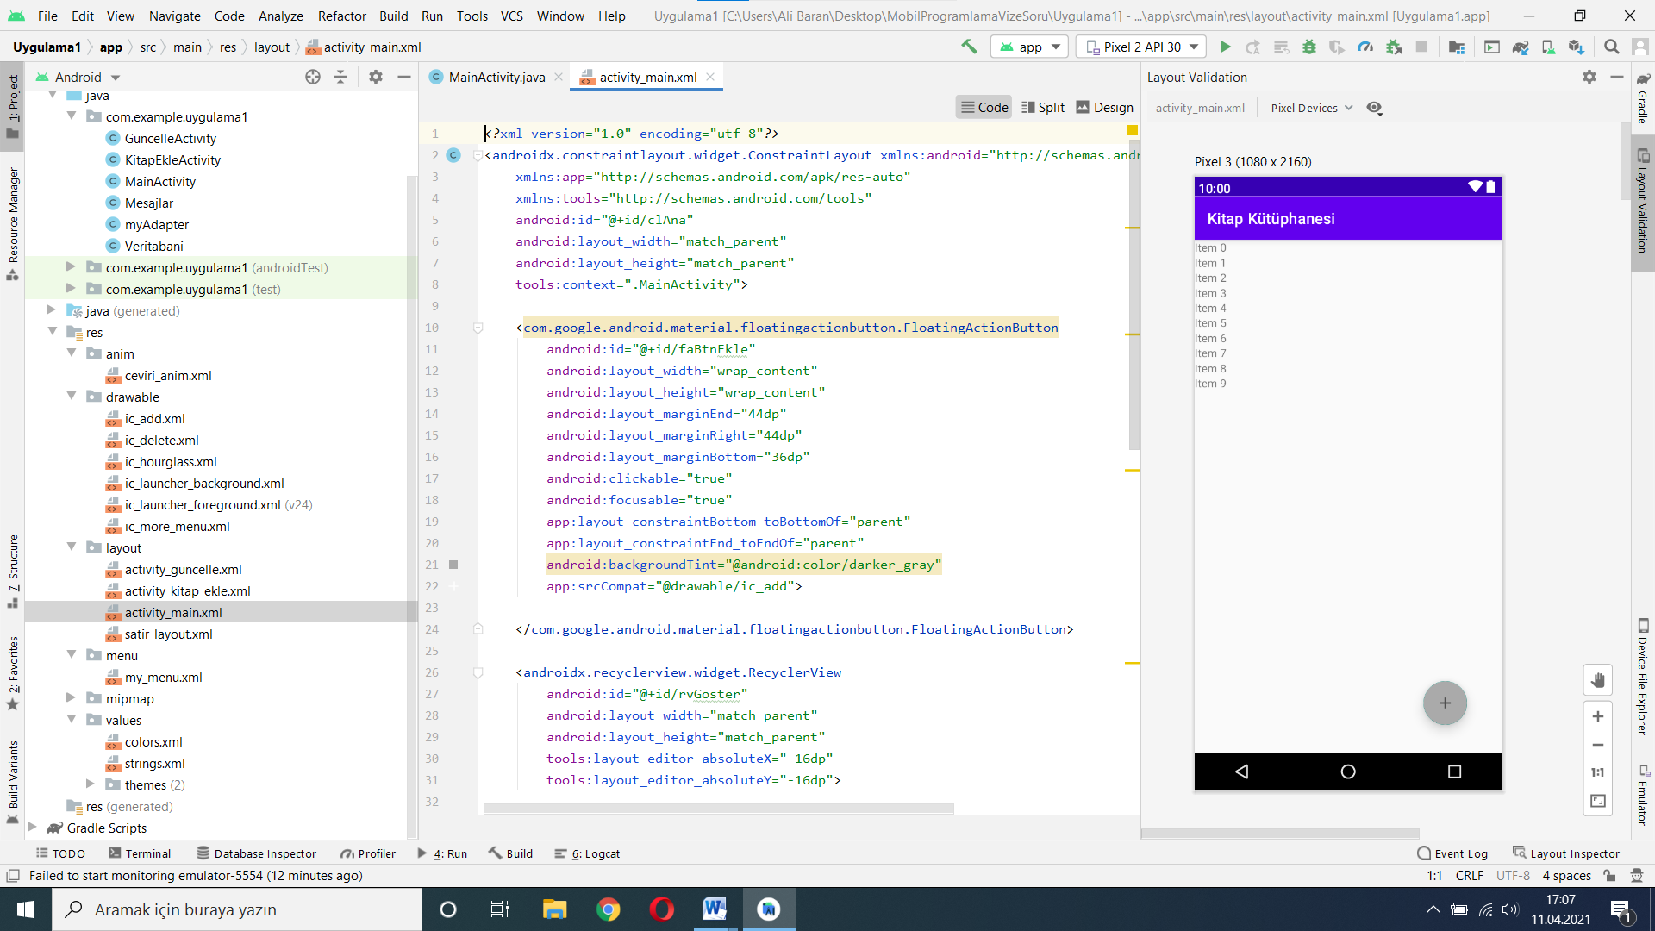

**Şekil 15.activity_main.xml**

KOD KISMI:

*<?*xml version="1.0" encoding="utf-8"*?>*<androidx.constraintlayout.widget.ConstraintLayout xmlns:android="http://schemas.android.com/apk/res/android"  
 xmlns:app="http://schemas.android.com/apk/res-auto"  
 xmlns:tools="http://schemas.android.com/tools"  
 android:id="@+id/clAna"  
 android:layout_width="match_parent"  
 android:layout_height="match_parent"  
 tools:context=".MainActivity">  
  
 <com.google.android.material.floatingactionbutton.FloatingActionButton  
 android:id="@+id/faBtnEkle"  
 android:layout_width="wrap_content"  
 android:layout_height="wrap_content"  
 android:layout_marginEnd="44dp"  
 android:layout_marginRight="44dp"  
 android:layout_marginBottom="36dp"  
 android:clickable="true"  
 android:focusable="true"  
 app:layout_constraintBottom_toBottomOf="parent"  
 app:layout_constraintEnd_toEndOf="parent"  
 android:backgroundTint="@android:color/darker_gray"  
 app:srcCompat="@drawable/ic_add">  
  
 </com.google.android.material.floatingactionbutton.FloatingActionButton>  
  
 <androidx.recyclerview.widget.RecyclerView  
 android:id="@+id/rvGoster"  
 android:layout_width="match_parent"  
 android:layout_height="match_parent"  
 tools:layout_editor_absoluteX="-16dp"  
 tools:layout_editor_absoluteY="-16dp">  
  
 </androidx.recyclerview.widget.RecyclerView>  
  
 <ImageView  
 android:id="@+id/ivVeriYok"  
 android:layout_width="81dp"  
 android:layout_height="65dp"  
 app:layout_constraintBottom_toBottomOf="parent"  
 app:layout_constraintEnd_toEndOf="parent"  
 app:layout_constraintStart_toStartOf="parent"  
 app:layout_constraintTop_toTopOf="parent"  
 app:layout_constraintVertical_bias="0.351"  
 app:srcCompat="@drawable/ic_hourglass"  
 android:alpha="0.1"  
 android:visibility="gone">  
  
 </ImageView>  
  
 <TextView  
 android:id="@+id/tvVeriYok"  
 android:layout_width="wrap_content"  
 android:layout_height="wrap_content"  
 android:layout_marginTop="20dp"  
 android:text="Kitap Yok."  
 android:textSize="22sp"  
 app:layout_constraintEnd_toEndOf="parent"  
 app:layout_constraintStart_toStartOf="parent"  
 app:layout_constraintTop_toBottomOf="@+id/ivVeriYok"  
 android:visibility="gone"  
 android:alpha="0.4"/>  
  
  
</androidx.constraintlayout.widget.ConstraintLayout>

MainActivity.java

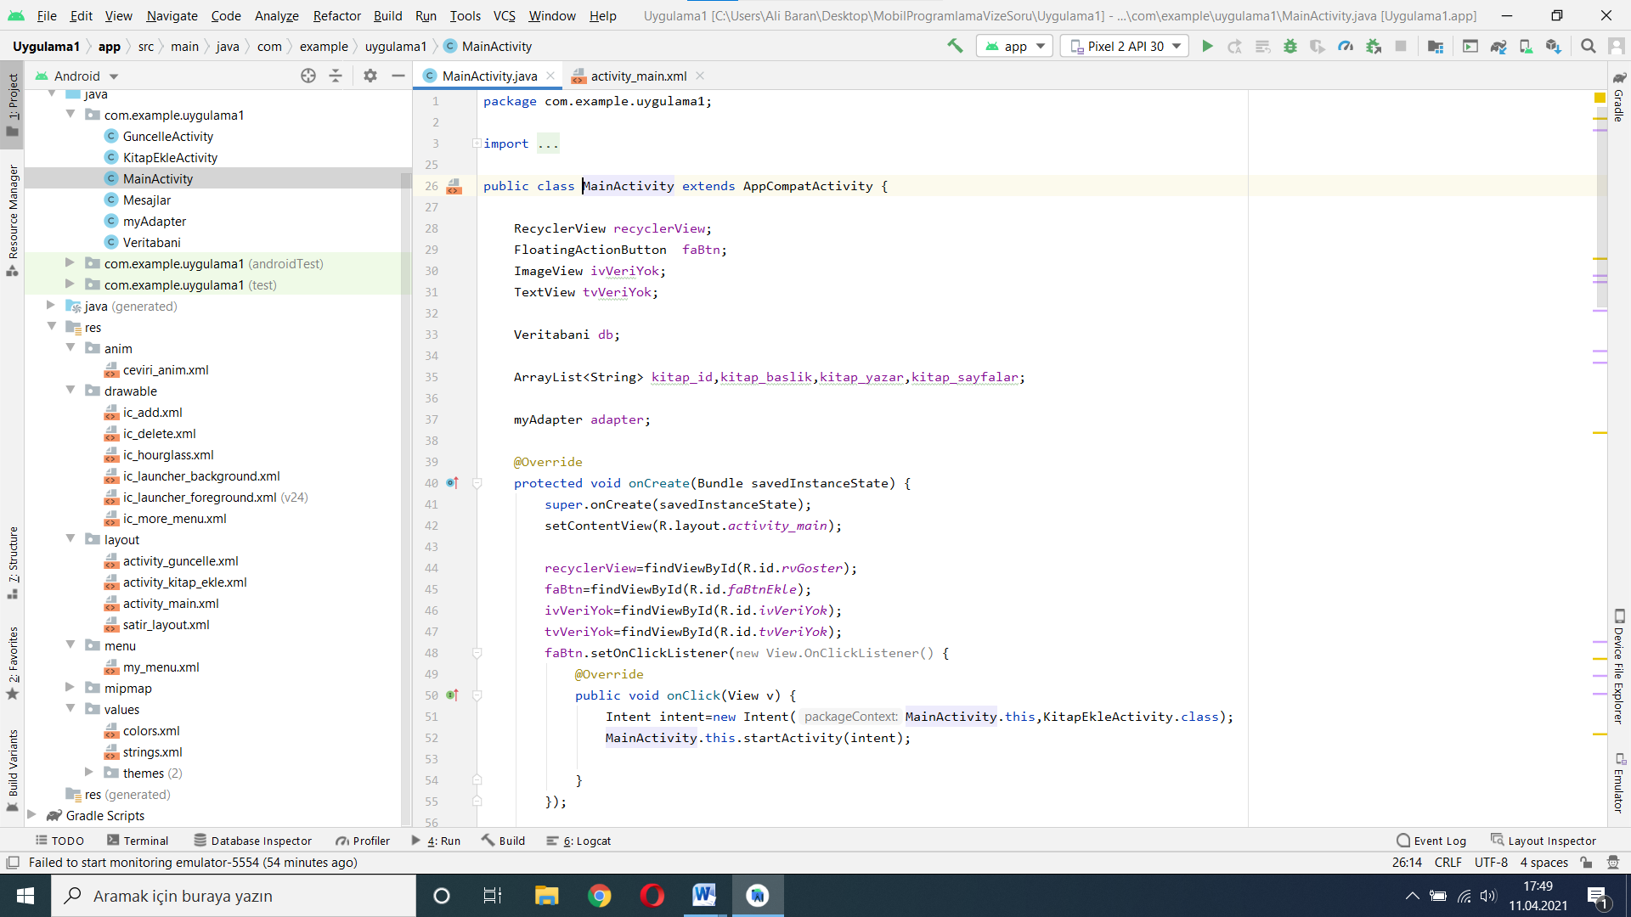

**Şekil 16.activity_main.java**

KOD KISMI:

import java.util. package com.example.uygulama1;  
  
import androidx.annotation.NonNull;  
import androidx.annotation.Nullable;  
import androidx.appcompat.app.AlertDialog;  
import androidx.appcompat.app.AppCompatActivity;  
import androidx.recyclerview.widget.LinearLayoutManager;  
import androidx.recyclerview.widget.RecyclerView;  
  
import android.content.DialogInterface;  
import android.content.Intent;  
import android.database.Cursor;  
import android.os.Bundle;  
import android.view.Menu;  
import android.view.MenuInflater;  
import android.view.MenuItem;  
import android.view.View;  
import android.widget.ImageView;  
import android.widget.TextView;  
import android.widget.Toast;  
  
import com.google.android.material.floatingactionbutton.FloatingActionButton;  
  
ArrayList;  
  
public class MainActivity extends AppCompatActivity {  
  
 RecyclerView recyclerView;  
 FloatingActionButton faBtn;  
 ImageView ivVeriYok;  
 TextView tvVeriYok;  
  
 Veritabani db;  
  
 ArrayList<String> kitap_id,kitap_baslik,kitap_yazar,kitap_sayfalar;  
  
 myAdapter adapter;  
  
 @Override  
 protected void onCreate(Bundle savedInstanceState) {  
 super.onCreate(savedInstanceState);  
 setContentView(R.layout.*activity_main*);  
  
 recyclerView=findViewById(R.id.*rvGoster*);  
 faBtn=findViewById(R.id.*faBtnEkle*);  
 ivVeriYok=findViewById(R.id.*ivVeriYok*);  
 tvVeriYok=findViewById(R.id.*tvVeriYok*);  
 faBtn.setOnClickListener(new View.OnClickListener() {  
 @Override  
 public void onClick(View v) {  
 Intent intent=new Intent(MainActivity.this,KitapEkleActivity.class);  
 MainActivity.this.startActivity(intent);  
  
 }  
 });  
  
 db=new Veritabani(MainActivity.this);  
 kitap_id=new ArrayList<>();  
 kitap_baslik=new ArrayList<>();  
 kitap_yazar=new ArrayList<>();  
 kitap_sayfalar=new ArrayList<>();  
  
 KitaplarıGoster();  
 adapter=new myAdapter(MainActivity.this,MainActivity.this,kitap_id,kitap_baslik,kitap_yazar,kitap_sayfalar);  
 recyclerView.setAdapter(adapter);  
 recyclerView.setLayoutManager(new LinearLayoutManager(MainActivity.this));  
  
 }  
  
 @Override  
 protected void onActivityResult(int requestCode, int resultCode, @Nullable Intent data) {  
 super.onActivityResult(requestCode, resultCode, data);  
 if (requestCode==1){  
 recreate();  
 }  
 }  
  
 void KitaplarıGoster(){  
 Cursor cursor=db.KitapListele();  
 if (cursor.getCount()==0){  
 ivVeriYok.setVisibility(View.*VISIBLE*);  
 tvVeriYok.setVisibility(View.*VISIBLE*);  
 }  
 else{  
 while (cursor.moveToNext()){  
 kitap_id.add(cursor.getString(0));  
 kitap_baslik.add(cursor.getString(1));  
 kitap_yazar.add(cursor.getString(2));  
 kitap_sayfalar.add(cursor.getString(3));  
  
 ivVeriYok.setVisibility(View.*GONE*);  
 tvVeriYok.setVisibility(View.*GONE*);  
 }  
 }  
 }  
  
  
 @Override  
 public boolean onCreateOptionsMenu(Menu menu) {  
 MenuInflater inflater=getMenuInflater();  
 inflater.inflate(R.menu.*my_menu*,menu);  
 return super.onCreateOptionsMenu(menu);  
 }  
  
 @Override  
 public boolean onOptionsItemSelected(@NonNull MenuItem item) {  
 if (item.getItemId() == R.id.*menuSil*){  
 SilmeOnayKutusu();  
 }  
 return super.onOptionsItemSelected(item);  
 }  
  
 void SilmeOnayKutusu(){  
 AlertDialog.Builder builder=new AlertDialog.Builder(MainActivity.this);  
 builder.setTitle("Hepsini Sil ?");  
 builder.setMessage("Hepsini silmek istediğinize emin misiniz?");  
 builder.setPositiveButton("Evet", new DialogInterface.OnClickListener() {  
 @Override  
 public void onClick(DialogInterface dialog, int which) {  
 Veritabani db=new Veritabani(MainActivity.this);  
 db.HepsiniKitapSil();  
  
 Intent intent=new Intent(MainActivity.this,MainActivity.class);  
 startActivity(intent);  
 finish();  
  
  
 }  
 });  
 builder.setNegativeButton("Hayır", new DialogInterface.OnClickListener() {  
 @Override  
 public void onClick(DialogInterface dialog, int which) {  
  
 }  
 });  
 builder.create().show();  
 }  
  
  
}

## activity_guncelleme.xml (30 puan)

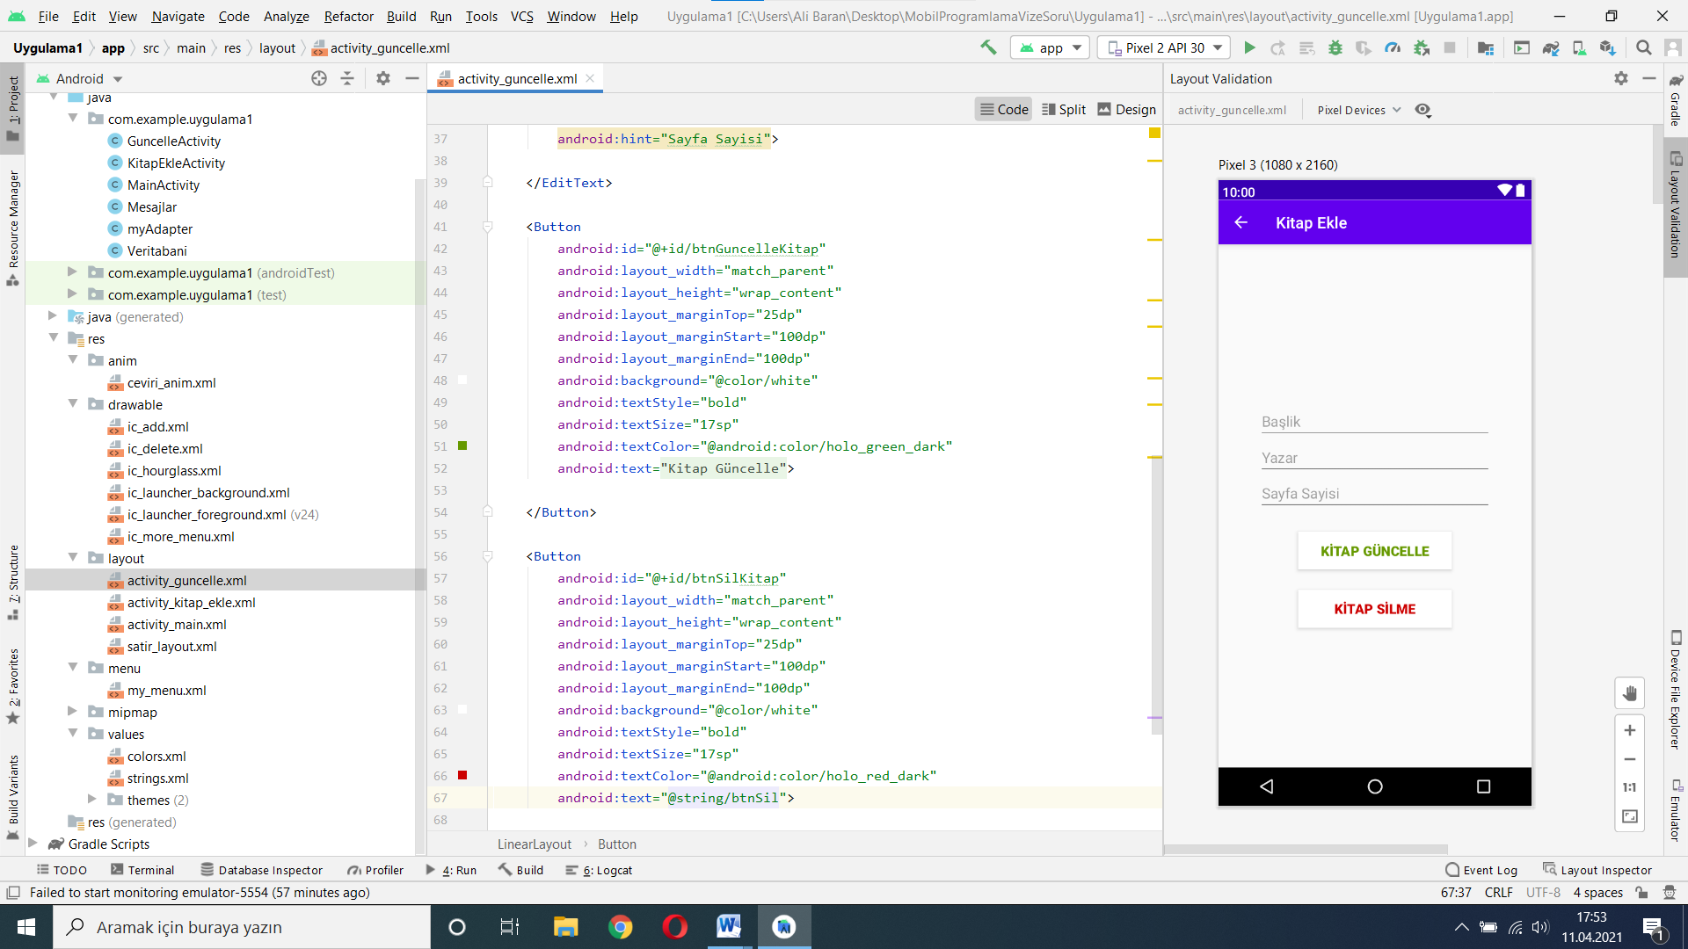

**Şekil 17.activity_guncelle.xml**

KOD KISMI:

*<?*xml version="1.0" encoding="utf-8"*?>*<LinearLayout xmlns:android="http://schemas.android.com/apk/res/android"  
 xmlns:app="http://schemas.android.com/apk/res-auto"  
 xmlns:tools="http://schemas.android.com/tools"  
 android:id="@+id/llGuncelle"  
 android:orientation="vertical"  
 android:layout_width="match_parent"  
 android:layout_height="match_parent"  
 tools:context=".KitapEkleActivity">  
  
  
 <EditText  
 android:id="@+id/etGuncelleBaslik"  
 android:layout_width="match_parent"  
 android:layout_height="wrap_content"  
 android:layout_marginTop="200dp"  
 android:layout_marginStart="50dp"  
 android:layout_marginEnd="50dp"  
 android:hint="Başlik">  
  
 </EditText>  
 <EditText  
 android:id="@+id/etGuncelleYazar"  
 android:layout_width="match_parent"  
 android:layout_height="wrap_content"  
 android:layout_marginStart="50dp"  
 android:layout_marginEnd="50dp"  
 android:hint="Yazar">  
  
 </EditText>  
 <EditText  
 android:id="@+id/etGuncelleSayfaSayisi"  
 android:layout_width="match_parent"  
 android:layout_height="wrap_content"  
 android:layout_marginStart="50dp"  
 android:layout_marginEnd="50dp"  
 android:hint="Sayfa Sayisi">  
  
 </EditText>  
  
 <Button  
 android:id="@+id/btnGuncelleKitap"  
 android:layout_width="match_parent"  
 android:layout_height="wrap_content"  
 android:layout_marginTop="25dp"  
 android:layout_marginStart="100dp"  
 android:layout_marginEnd="100dp"  
 android:background="@color/white"  
 android:textStyle="bold"  
 android:textSize="17sp"  
 android:textColor="@android:color/holo_green_dark"  
 android:text="@string/btnGuncelle">  
  
 </Button>  
  
 <Button  
 android:id="@+id/btnSilKitap"  
 android:layout_width="match_parent"  
 android:layout_height="wrap_content"  
 android:layout_marginTop="25dp"  
 android:layout_marginStart="100dp"  
 android:layout_marginEnd="100dp"  
 android:background="@color/white"  
 android:textStyle="bold"  
 android:textSize="17sp"  
 android:textColor="@android:color/holo_red_dark"  
 android:text="@string/btnSil">  
  
 </Button>  
  
  
  
  
</LinearLayout>

## activity_ekle.xml (10 puan)

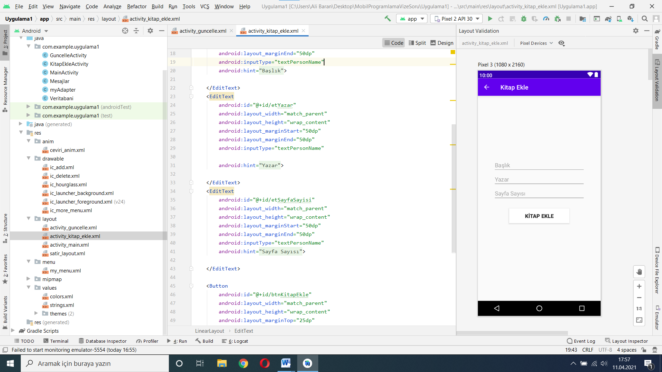

**Şekil18.activity_kitap_ekle.xml**

Kod kısmı:

*<?*xml version="1.0" encoding="utf-8"*?>*<LinearLayout xmlns:android="http://schemas.android.com/apk/res/android"  
 xmlns:app="http://schemas.android.com/apk/res-auto"  
 xmlns:tools="http://schemas.android.com/tools"  
 android:id="@+id/llEkle"  
 android:orientation="vertical"  
 android:layout_width="match_parent"  
 android:layout_height="match_parent"  
 tools:context=".KitapEkleActivity">  
  
  
 <EditText  
 android:id="@+id/etBaslik"  
 android:layout_width="match_parent"  
 android:layout_height="wrap_content"  
 android:layout_marginTop="200dp"  
 android:layout_marginStart="50dp"  
 android:layout_marginEnd="50dp"  
 android:inputType="textPersonName"  
 android:hint="@string/etBaslik">  
  
 </EditText>  
 <EditText  
 android:id="@+id/etYazar"  
 android:layout_width="match_parent"  
 android:layout_height="wrap_content"  
 android:layout_marginStart="50dp"  
 android:layout_marginEnd="50dp"  
 android:inputType="textPersonName"  
  
 android:hint="@string/etYazar">  
  
 </EditText>  
 <EditText  
 android:id="@+id/etSayfaSayisi"  
 android:layout_width="match_parent"  
 android:layout_height="wrap_content"  
 android:layout_marginStart="50dp"  
 android:layout_marginEnd="50dp"  
 android:inputType="textPersonName"  
 android:hint="@string/etSayfaSayisi">  
  
 </EditText>  
  
 <Button  
 android:id="@+id/btnKitapEkle"  
 android:layout_width="match_parent"  
 android:layout_height="wrap_content"  
 android:layout_marginTop="25dp"  
 android:layout_marginStart="100dp"  
 android:layout_marginEnd="100dp"  
 android:background="@color/white"  
 android:textStyle="bold"  
 android:textSize="17sp"  
 android:text="@string/btnKitapEkle">  
  
 </Button>  
  
</LinearLayout>

## Layout_menu.xml (10 puan)

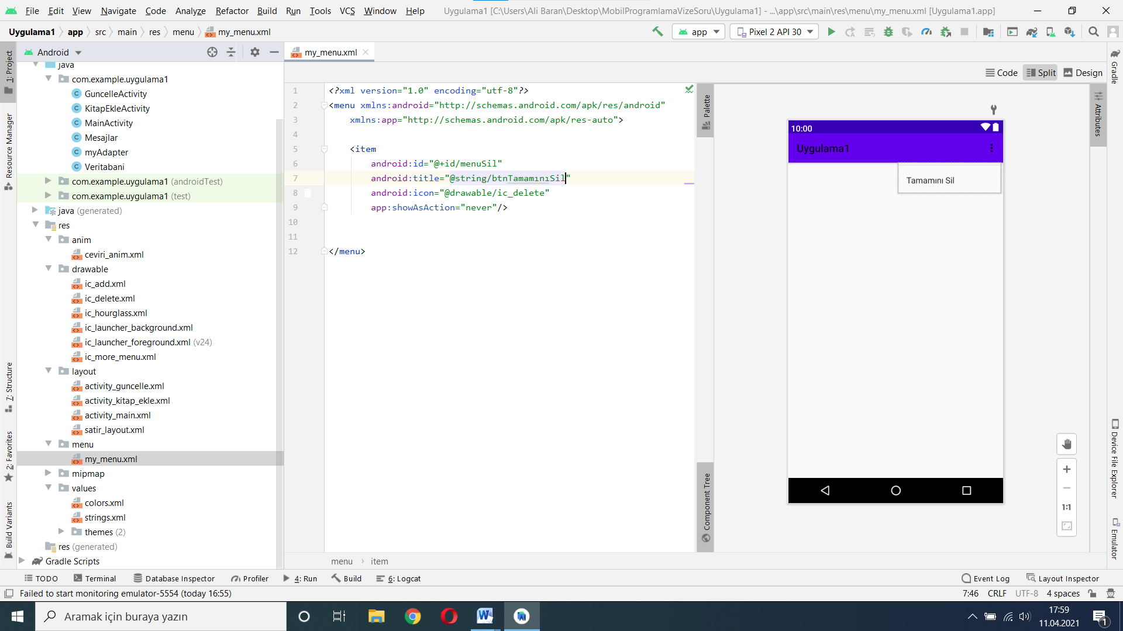

**Şekil 19.my_menu.xml**